|  |  |  |  |  |  |  |  |  |  |
| --- | --- | --- | --- | --- | --- | --- | --- | --- | --- |
| **SCHOOL OF COMPUTER SCIENCE AND ARTIFICIAL INTELLIGENCE** | | | | | **DEPARTMENT OF COMPUTER SCIENCE ENGINEERING** | | | | |
| **Program Name:** B. Tech | | | | **Assignment Type: Lab** | | | **Academic Year:**2025-2026 | | |
| **Course Coordinator Name** | | | | Venkataramana Veeramsetty | | | | | |
| **Instructor(s) Name** | | | | |  | | --- | | Dr. V. Venkataramana (Co-Ordinator) | | Dr. T. Sampath Kumar | | Dr. Pramoda Patro | | Dr. Brij Kishor Tiwari | | Dr.J.Ravichander | | Dr. Mohammand Ali Shaik | | Dr. Anirodh Kumar | | Mr. S.Naresh Kumar | | Dr. RAJESH VELPULA | | Mr. Kundhan Kumar | | Ms. Ch.Rajitha | | Mr. M Prakash | | Mr. B.Raju | | Intern 1 (Dharma teja) | | Intern 2 (Sai Prasad) | | Intern 3 (Sowmya) | | NS_2 ( Mounika) | | | | | | |
| **Course Code** | | | 24CS002PC215 | **Course Title** | | AI Assisted Coding | | | |
| **Year/Sem** | | | II/I | **Regulation** | | R24 | | | |
| **Date and Day**  **of Assignment** | | | Week2 - Monday | **Time(s)** | |  | | | |
| **Duration** | | | 2 Hours | **Applicable to**  **Batches** | |  | | | |
| **Assignment Number:4.1**(Present assignment number)/**24**(Total number of assignments) | | | | | | | | | |
|  | | | | | | | | | |
|  | **Q.No.** | **Question** | | | | | | ***Expected Time***  ***to complete*** |  |
|  | 1 | Lab 4: Advanced Prompt Engineering – Zero-shot, One-shot, and Few-shot Techniques  **Lab Objectives:**   * To explore and apply different levels of prompt examples in AI-assisted code generation. * To understand how zero-shot, one-shot, and few-shot prompting affect AI output quality. * To evaluate the impact of context richness and example quantity on AI performance. * To build awareness of prompt strategy effectiveness for different problem types.   **Lab Outcomes (LOs):**  After completing this lab, students will be able to:   * Use zero-shot prompting to instruct AI with minimal context. * Use one-shot prompting with a single example to guide AI code generation. * Apply few-shot prompting using multiple examples to improve AI responses. * Compare AI outputs across the three prompting strategies.   **Task #1 – Zero-Shot Prompting with Conditional Validation**  Objective  Use zero-shot prompting to instruct an AI tool to generate a function that validates an Indian mobile number.  Requirements   * The function must ensure the mobile number:   + Starts with 6, 7, 8, or 9   + Contains exactly 10 digits   Expected Output   * A valid Python function that performs all required validations without using any input-output examples in the prompt.   **Task #2 – One-Shot Prompting with Edge Case Handling**  Objective  Use one-shot prompting to generate a Python function that calculates the factorial of a number.  Requirements   * Provide one sample input-output pair in the prompt to guide the AI. * The function should handle:   + 0! correctly   + Negative input by returning an appropriate message   Expected Output   * A Python function with correct factorial logic and edge case handling, generated from a single example.   **Task #3 – Few-Shot Prompting for Nested Dictionary Extraction**  Objective  Use few-shot prompting (2–3 examples) to instruct the AI to create a function that parses a nested dictionary representing student information.  Requirements   * The function should extract and return:   + Full Name   + Branch   + SGPA   Expected Output   * A reusable Python function that correctly navigates and extracts values from nested dictionaries based on the provided examples.   **Task #4 – Comparing Prompting Styles for File Analysis**  Objective  Experiment with zero-shot, one-shot, and few-shot prompting to generate functions for CSV file analysis.  Requirements   * Each generated function should:   + Read a .csv file   + Return the total number of rows   + Count the number of empty rows   + Count the number of words across the file   Expected Output   * Working Python functions for each prompting style, with a brief reflection comparing their accuracy, clarity, and efficiency.   **Task #5 – Few-Shot Prompting for Text Processing and Word** **Frequency**  Objective  Use few-shot prompting (with at least 3 examples) to generate a Python function that processes text and analyzes word frequency.  Requirements  The function must:   * Accept a paragraph as input * Convert all text to lowercase * Remove punctuation * Return the most frequently used word   Expected Output   * A functional Python script that performs text cleaning, tokenization, and returns the most common word using only the examples provided in the prompt   **Note:** Report should be submitted a word document for all tasks in a single document with prompts, comments & code explanation, and output and if required, screenshots  **Evaluation Criteria:**   | **Criteria** | **Max Marks** | | --- | --- | | Zero Shot (Task #1) | 0.5 | | One Shot (Task#2) | 0.5 | | Few Shot (Task#3, Task#4 & Task #5) | 1.5 | | **Total** | **2.5 Marks** | | | | | | | Week2 - Monday |  |

TASK 1 in visual studio:

Prompt: **Develop a python function that checks wheather its an Indian phone number or not?**

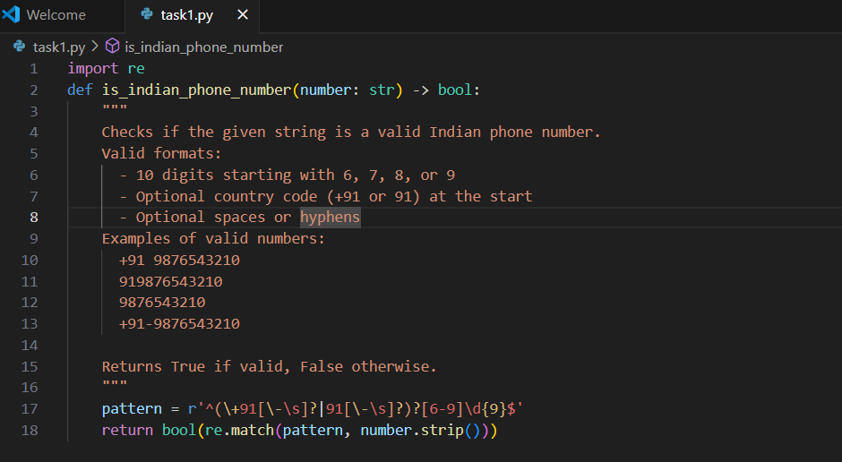

**OUTPUT:**

**In cursor AI:**

**Prompt: Develop a python function that checks wheather its an Indian phone number or not?with an example input should’nt be given by used**

TASK2 :

Prompt: develop a python function that generates factorial of a given number ex: factorial of 5= 120 now you find factorial of 8?

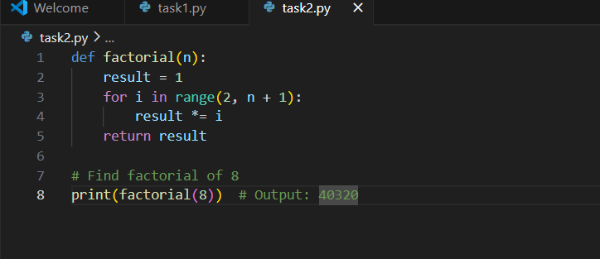

**OUTPUT:**



**In cursor Ai:**

**Prompt:** develop a python function that generates factorial of a given number ex: factorial of 5= 120 now you find factorial of 8?

**OUTPUT:**



**TASK3:**

**Prompt:** **: create a function that parses a nested dictionary representing student information. EX:1full name:challa vyshu ,branch: cse ,cgpa:9.8 EX2: full name:pandu reddy ,branch: ECE , CGPA:10 now based on these examples you create an another one**

**Code in visual studio:**

**OUTPUT:  
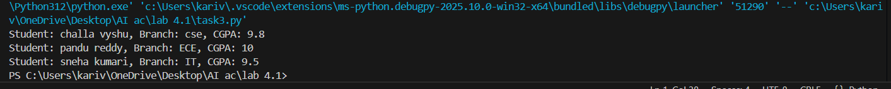**

**In cursor Ai:**

**Prompt: create a function that parses a nested dictionary representing student information. EX:1full name:challa vyshu ,branch: cse ,cgpa:9.8 EX2: full name:pandu reddy ,branch: ECE , CGPA:10 now based on these examples you create an another one**

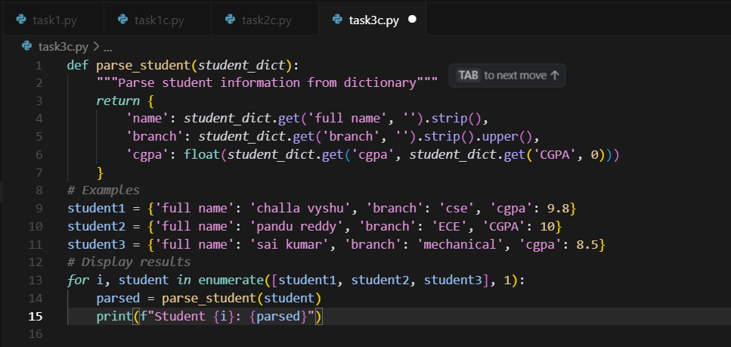

**OUTPUT:**

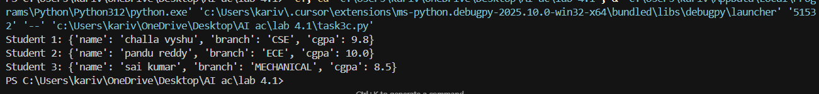

**TASK4:**

**PROMPT:** generate functions for CSV file analysis.

Requirements

* Each generated function should:
  + Read a .csv file
  + Return the total number of rows
  + Count the number of empty rows
  + Count the number of words across the file

CODE In VISUAL STUDIO:

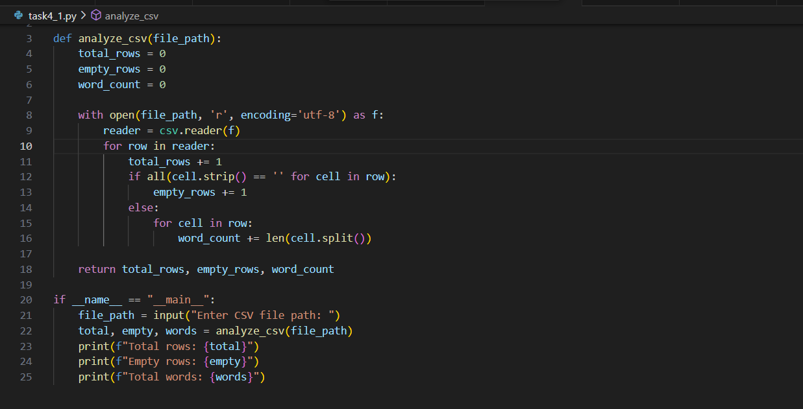

**OUTPUT:**

**TASK5:**

**Prompt: : generate a Python function that processes text and analyzes word frequency.**

**Requirements**

**The function must:**

* **Accept a paragraph as input**
* **Convert all text to lowercase**
* **Remove punctuation**
* **Return the most frequently used word**

**Ex1:rain rain go away**

**Expected output:rain**

**Ex2:I can dance,I can walk,I can run,eat,sleep**

**Expected output: i**

**Ex3: vyshu is a brilliant,intelligent ,and vyshu is a multitalent vyshu can do anything**

**Expected output:vyshu**

**By the above examples create an another one for me?**

**IN VISUAL STUDIO:**

**OUTPUT:**



**IN CURSOR AI:  
PROMPT: generate a Python function that processes text and analyzes word frequency.**

**Requirements**

**The function must:**

* **Accept a paragraph as input**
* **Convert all text to lowercase**
* **Remove punctuation**
* **Return the most frequently used word**

**Ex1:rain rain go away**

**Expected output:rain**

**Ex2:I can dance,I can walk,I can run,eat,sleep**

**Expected output: i**

**Ex3: vyshu is a brilliant,intelligent ,and vyshu is a multitalent vyshu can do anything**

**Expected output:vyshu**

**By the above examples create an another one for me?**

**OUTPUT:  
**

